**KNN OUTLIER DETECTION TECHNIQUES….. SOLVED PROBLEMS FOR PRACTICE**

Consider a two feature dataset with objects O1(1,1,), O2(5,2), O3(2,3), O4(1,2) and O5(2,1). Apply **distance based algorithm** for outlier identification, considering the distance threshold of 2.5 and fraction threshold of 0.40. Illustrate the steps in identifying the outlier.

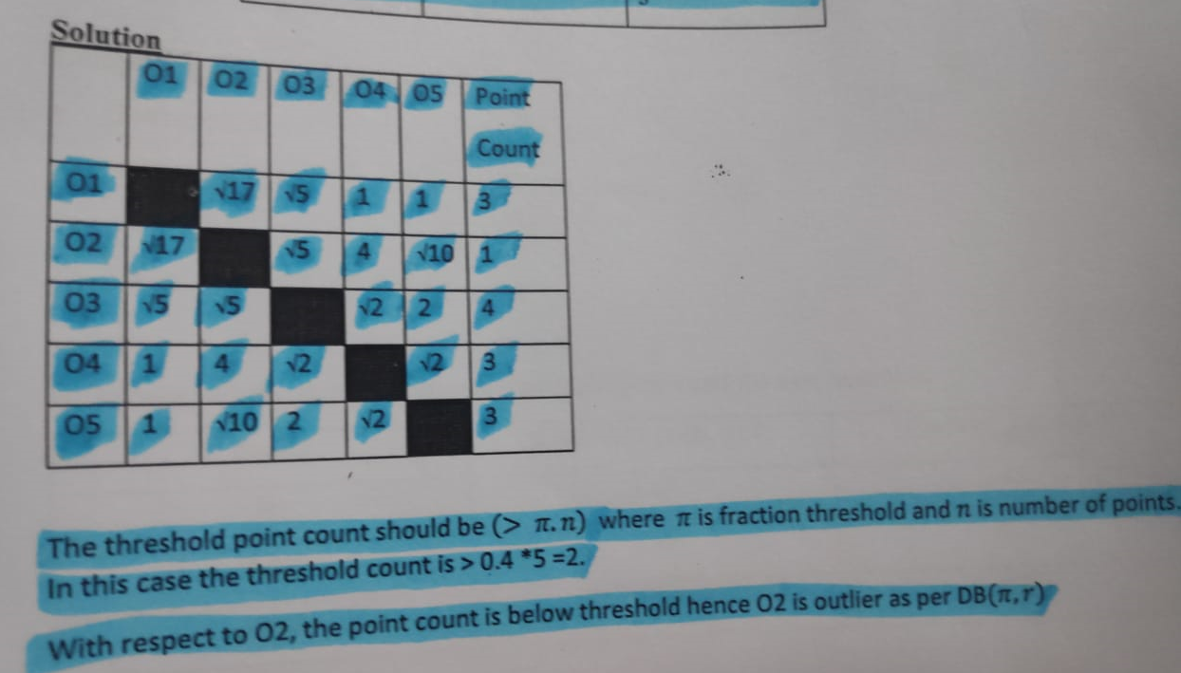

Consider the distance matrix provided for data objects. The outlier score of an object is the inverse of the density around an object. The density of an object is equal to the number of objects that are within a distance of 3 units from the object. Identify the outlier using the density-based outlier detection method.

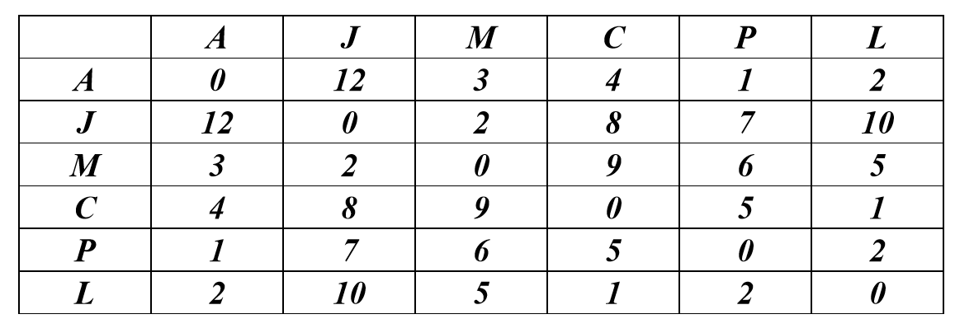

FOR K=3,

O(A)=(1+2+3)/3=2 ;;

O(J)=(2+7+8)/3=5.66

O(M)=(2+3+5)/3=3.33

O(C)=(1+4+5)/3=3.33

O(P)=(1+2+5)/3=2.66

O(L)=(1+2+2)/3=1.66

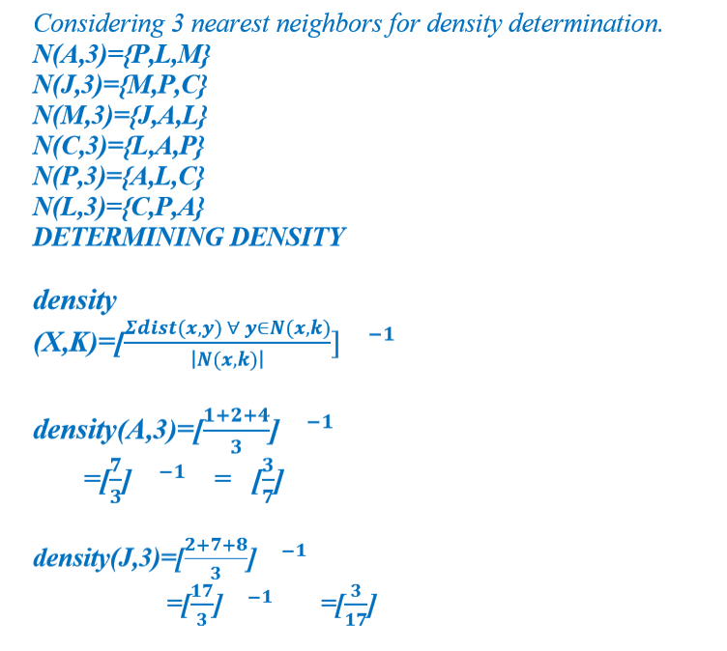

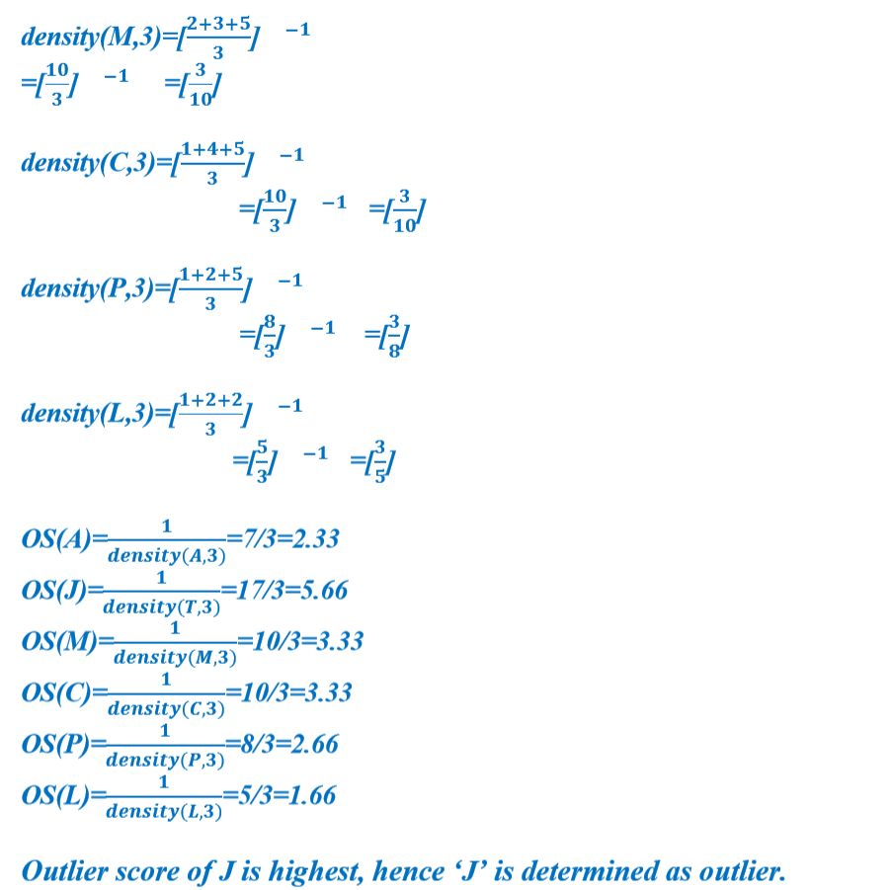

Consider the distance matrix provided for data objects. The outlier score of an object is the inverse of the density around an object. The density of an object is equal to the number of objects that are within a distance of 3 units from the object. Identify the outlier using the **density-based outlier detection method.**

